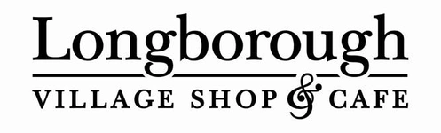
Kings Award Nomination



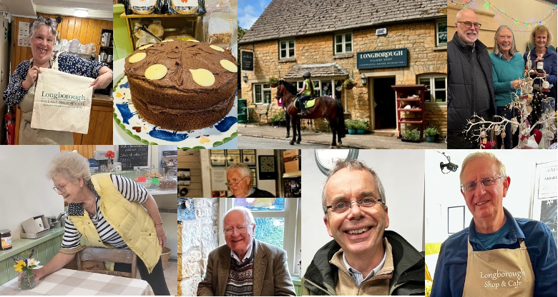

Many of you already know how special our village Community Shop and Café are. What some may not know is that it has recently been nominated for the King’s Award for Voluntary Service. This is the highest award given to volunteer groups in the UK. It is the equivalent to an MBE and is presented for life.
This nomination recognises all the volunteers who have over the past 18 years, since we became a Community Enterprise kept the shop and café running day after day, often quietly and without fuss, but always with kindness, care and a strong sense of community.
When news of the nomination was shared locally, the response from villagers was overwhelming. Emails, messages and comments poured in, all saying much the same thing in different ways: that the shop is far more than a place to collect the paper, buy milk or have a coffee.
As one member of the village put it:
“Our village shop is, in many ways, the beating heart of our village.”
For others, especially those living alone, the reassurance it brings is invaluable:
“I very much value the support and help from our shop. Words cannot adequately describe the comfort of knowing it is there.”
Visitors notice it too. One guest staying in the village wrote:
“The team were superb… friendly, chatty and helpful every time we visited. The bacon sandwiches and coffees were delicious, and it felt like the centre of village life.”
What shines through all these messages is not just appreciation for the service, but gratitude for the people behind it. The volunteers who go out of their way to help and who create a place where everyone feels welcome.
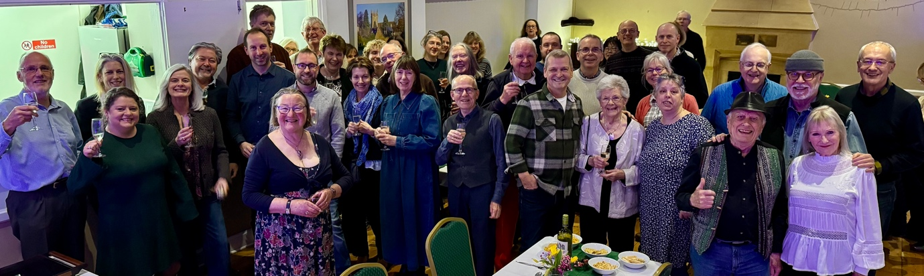
Whether or not the Kings Award nomination leads to the final award, it already reflects something the village already knows well: Longborough’s Shop and Café is built on generosity, care and a strong community spirit. That is something worth celebrating.

In January we invited all our current volunteers, together with the partners to join us in village hall as a thank you and to celebrate another great year in the shop. The feeling of community spirit was so lovely and it was a brilliant evening with entertainment, a quiz and live music.
The decision for the Kings Award will be made toward the end of this year, so we will keep you informed as we progress. Lets keep our fingers crossed.
Spring Shop Windows
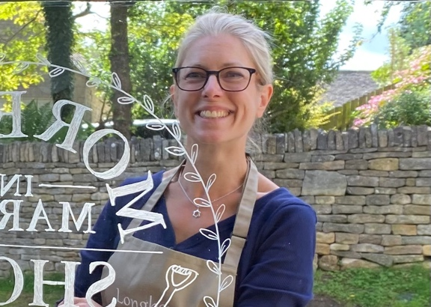
Our Kings Award nomination wouldn’t have been complete without a special mention for Anna, our longest-serving volunteer, whose creativity has brought colour and joy to the village through the shop windows for many years.
Anna has been the incredible talent behind the ever-changing window displays that mark the seasons and make people stop, smile, and often come in “just for a look” . From the incredible Christmas window to the recent Pets window, each display is full of imagination, care and unmistakable village spirit.
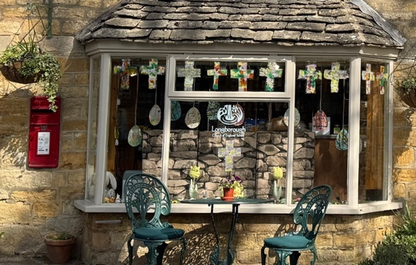
As we move into spring, Anna has once again transformed the windows with “Spring is in the Air”, capturing the sense of optimism and renewal that the shop represents for so many. And as Easter approaches, she will, again, hand over the reins to Longborough School, whose Easter window, designed and created by the children themselves is another highlight of the year.
With so much creativity, community involvement and enthusiasm on show, there is plenty to look forward to in 2026.
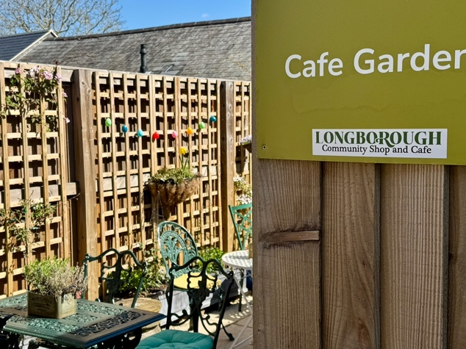
Garden Opening
There’s more good news to look forward to this spring. From 4th April, the shop and café will be extending its opening hours, giving villagers and visitors more time to enjoy everything it has to offer.
With the warmer weather returning, the garden will reopen, providing a lovely spot to sit with a coffee, catch up with friends, or simply enjoy the village atmosphere. On Saturdays, the café will now be open until 4pm, and on Sundays until 2pm, making it easier than ever to drop in after a walk, a cycle, or a relaxed weekend lunch.
As always, these extended hours are made possible by our volunteers, and we look forward to welcoming everyone to make the most of the extra time together.
Kitchen Project
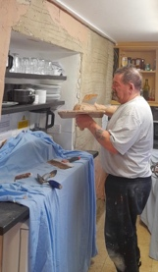
Work in the kitchen is finally getting underway. Buster has finished the plastering and and during March we will be replacing all the units with stainless steel and upgrading the old freezers with more efficient cabinets.

By the summer, we will have a fully refitted kitchen, thanks to the generosity of the village through last year’s crowd funding and donations from the Parish Council and LASCA.

Shop AGM

A date for your calendars! This year’s Shop AGM will be held on Tuesday April 21st in the
Village Hall. Stay tuned for more details on the Longborough News emails.
If you would like to become a shareholder in the shop, then shares are available at £10 each, if you are interested, please speak to any of the team.
We invite you to join us at the AGM to hear last year’s highlights, share your thoughts, and ask the
Committee any questions. Your input is invaluable, and we always love hearing from our
community. So see you there!

Sales Update

As a little preview to the AGM, the following graph shows how sales in 2025 compared
with the previous 5 years. Our costs have gone up every year. However, we have continued to keep prices down and our margin as low as possible over these difficult times.
As the graph shows, sales were about 8% higher last year than 2024 and we had another good summer and Christmas.
The shop has again made a similar profit to 2024, which is a great result.
This has enabled us to invest in the shop this year with the kitchen improvements, which take place in March.

