
Village Shop
Spring 2025
Spring Sunshine and Something Refreshing
With the warm weather arriving early this spring, there’s no better time to visit the shop and enjoy a little treat in our lovely café garden. We’ve introduced some refreshing new cold drinks to help you cool down, including freshly made iced coffee — perfect for a sunny afternoon pick-me-up!
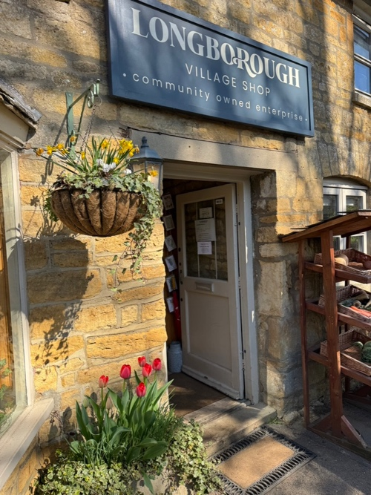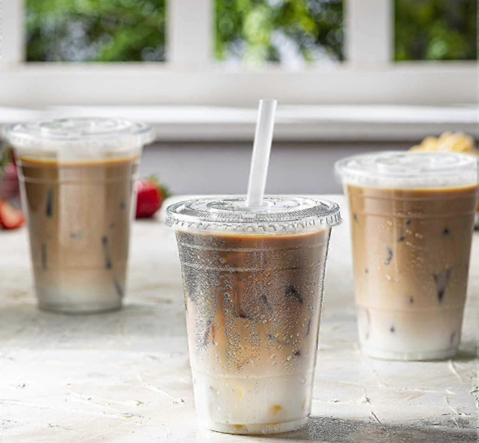
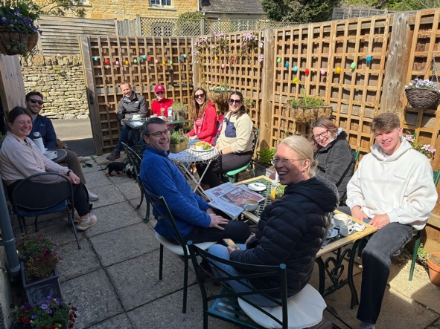
The garden is looking especially beautiful right now, full of colourful blooms and lush greenery. It’s a peaceful, shady spot to relax, chat with friends, or simply enjoy a quiet moment with a drink in hand. Whether you stay for five minutes or an hour, you’re always welcome — come and soak up the sunshine with us!

Celebrating Our Local Heroes – A Tribute to Our Suppliers
This March, we dedicated our entire shop window to our hardworking local suppliers who help us bring fresh, high-quality produce to Longborough every single day. It’s thanks to their dedication and support that we can continue offering the kind of food that our community values – fresh, local, and full of flavour.
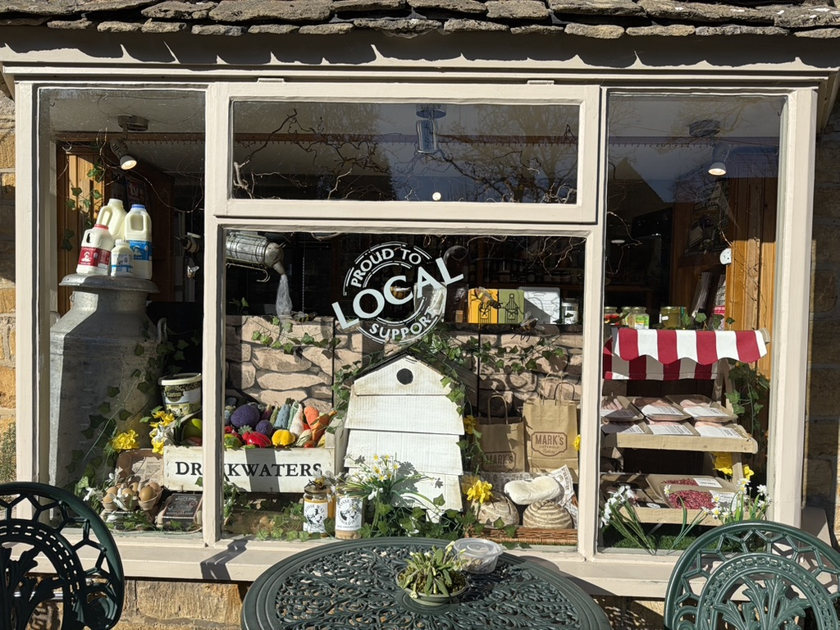
We’re proud to work with many of these wonderful suppliers for many years. Supporting local isn’t just something we say – it’s something we do every day. From the rural farms to our shelves, their efforts make all the difference.
Our village is lucky to have such incredible producers right on our doorstep. Whether you’re a local or just visiting, you’ve likely enjoyed:
- Eggs from Billy
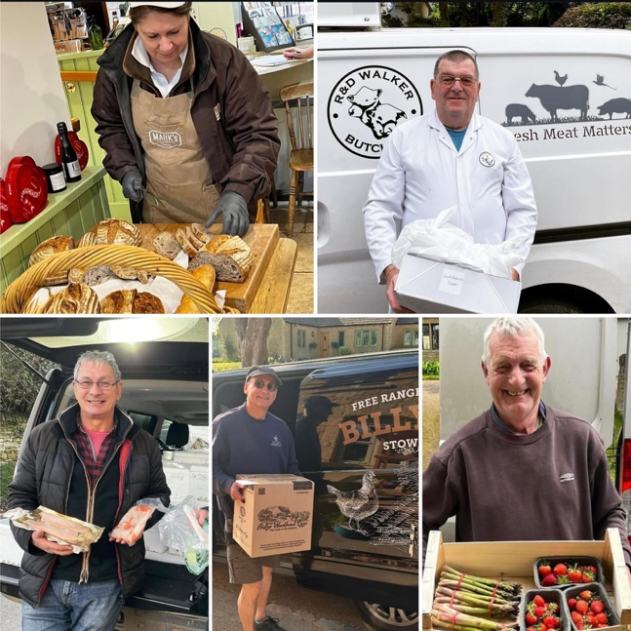
- Bread from Mark
- Meat from Rob
- Fish from Nick
- Vegetables from the Drinkwaters

All these suppliers come from just a few miles around Longborough, and they remain some of our most popular items – not just for their quality, but for the care behind them.
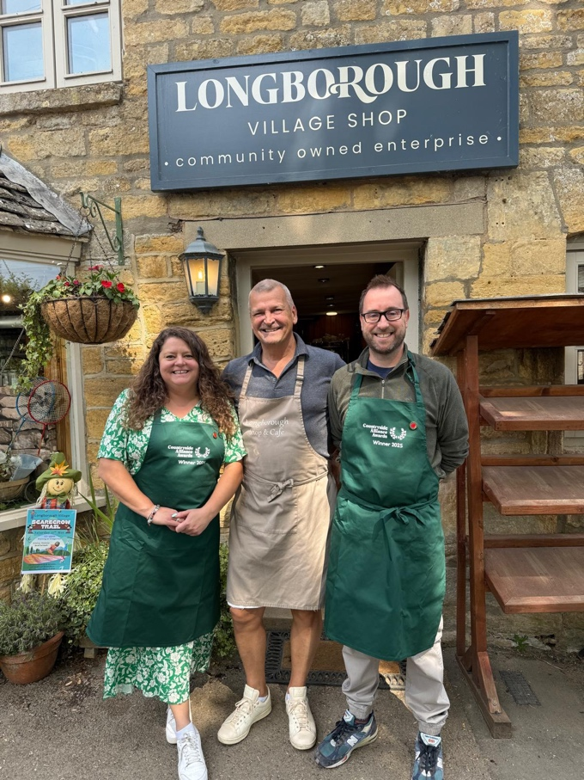
Celebrating Winning the Countryside Alliance Award
We are thrilled to announce that this spring, Longborough Village Shop was honoured with the South West Regional Award for Best Village Shop by the Countryside Alliance. Known as the “Rural Oscars,” these awards celebrate rural businesses that go the extra mile to support their communities and local economies.
This recognition is a testament to the dedication of our staff, volunteers, and the unwavering support from our community. Competing against numerous outstanding shops across the South West, we are proud to have been selected as regional champions.
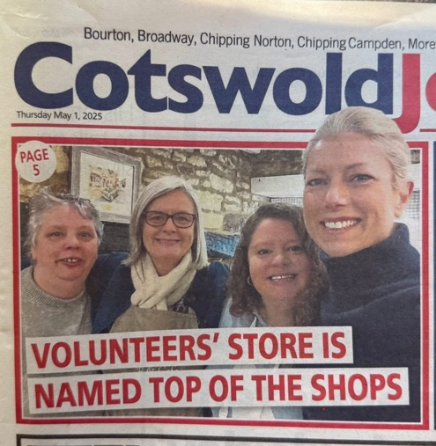

As regional winners, we have been invited to the national champions’ reception at the House of Lords in June. There, we will join other regional winners from across the UK to celebrate rural excellence and discover who will be crowned the national champion in our category.
This achievement reflects the collective effort of our entire community. Thank you for your continued support.

Welcome, Silke
As we announced in January, we bid a fond farewell to Jo Shaw, whose warmth and friendliness made her a cherished member of our team Jo is greatly missed, and we wish her all the best in her future endeavours.
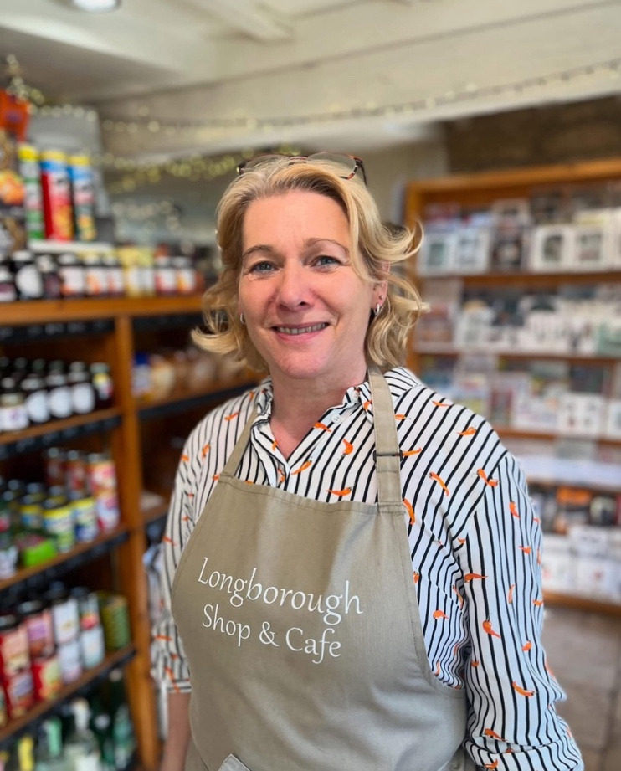
We are delighted to now welcome Silke Bruening to join our team. Silke brings a wealth of experience, having previously run her own coffee shop, Cacao Bean, on Moreton-in-Marsh High Street. A trained pastry chef, Silke has worked in prestigious kitchens, including the Dorchester, St Martins Lane, and Sanderson Hotel in London. Her passion for baking began in Bremen, Germany, and has taken her through various esteemed establishments in Berlin, Munich, and London.
Since joining us, Silke has infused our shop with fresh ideas and energy. We eagerly anticipate sampling her delicious cakes in the coming months. Please join us in giving Silke a warm welcome to our community!

Farewell to Miron, and a Warm Welcome to Tim
We recently said goodbye to Miron Darby, who has been a valued part of our team since 2019. Miron’s cheerful presence and dedication will be greatly missed, and we thank him for all his hard work and energy he brings to the shop and cafe. Miron has been with us (on ands off) since he was 14, starting on Saturdays and coming back as a full member of the team last year. He is now off to pastures new and we wish him all the best.
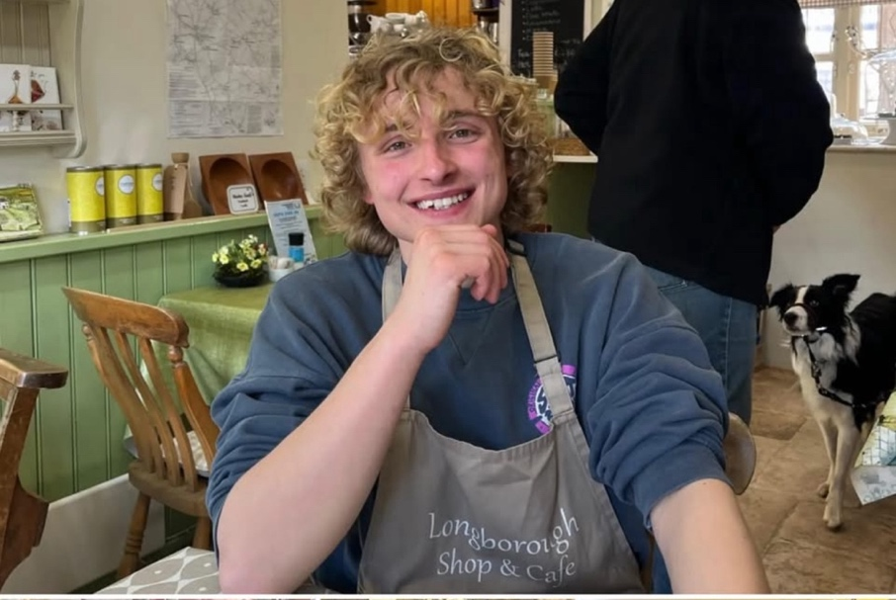
Stepping into the role left by Miron is Tim Orr who now works with Becky in the week and runs the shop on alternate weekends alongside our fantastic new team of young staff and volunteers. Tim has gained a wealth of experience over the years from his career in media, having worked in Dubai for several years before recently returning to the UK. Now based in Chipping Campden, Tim is enjoying immersing himself in Longborough village life.
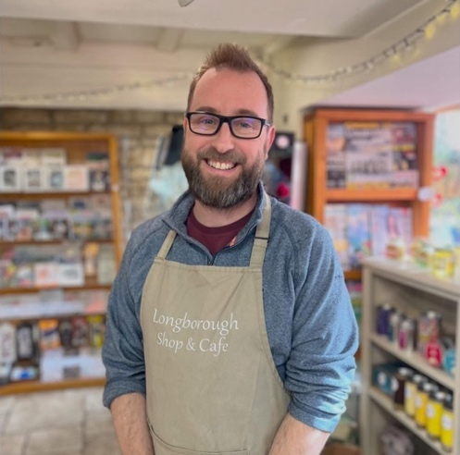
We’re delighted to have Tim on board and look forward to the fresh perspectives he brings to our operations. Please join us in giving him a warm welcome next time you visit the shop!

A Big Thank You to Charles – and the Parish Council
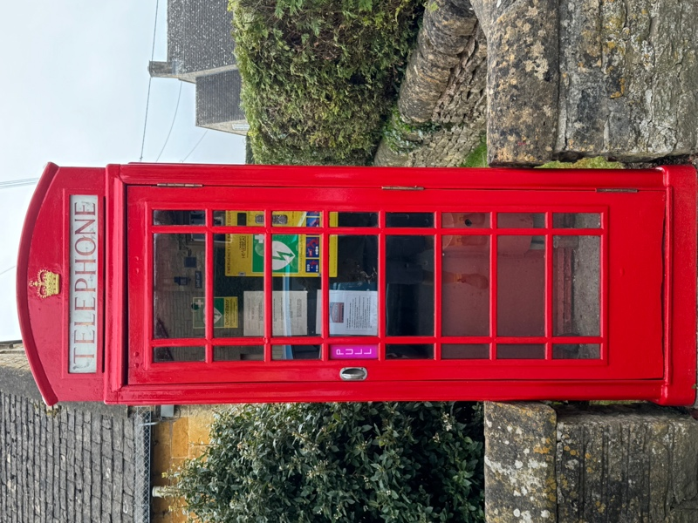
If you’ve wandered down Longborough High Street lately, you may have spotted our iconic red telephone box looking freshly spruced up — all thanks to the hard work of Charles Taverner. Charles, a resident of over 20 years and Secretary of the Village Shop Committee, volunteered this Spring to take on the task of restoring this beloved piece of village history.
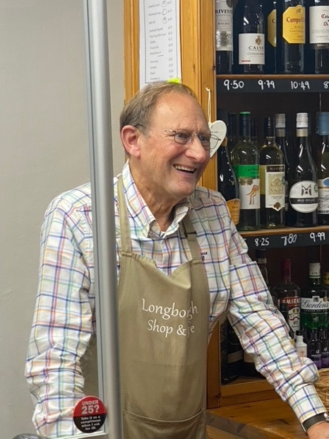
Originally designed in 1935 to mark King George V’s Silver Jubilee, our K6 phone box is not just a charming feature — it now houses a public access defibrillator, an important, potentially life-saving resource for the village.

We’re hugely grateful to Charles for giving up his time and skills to bring the box back to life, and to the Parish Council for kindly funding the materials needed for the restoration. It’s a great example of community spirit in action — preserving the past while helping to protect the present.

Caption Competition
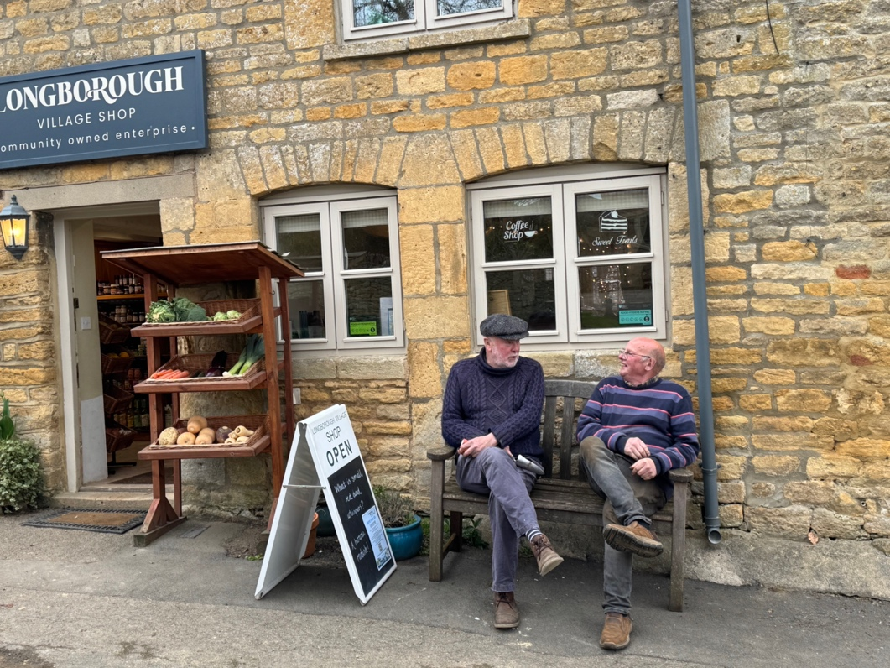
You may have noticed that we have a new bench outside the shop and it didn't take long for these likely lads to make use of it. There is a small prize for the best idea of what John is saying to Stuart?
Our first suggestion is:
"She said, ‘Buy bread and milk.’ I heard, ‘Sit on a bench and contemplate life.’ Close enough."

Financials
At the AGM in April we were delighted to share that 2024 was a fantastic year for Longborough Village Shop. Thanks to your support, gross sales reached £252,000, with net sales at £224,000 — a 26% increase on 2023! We smashed our original target of £214,000, generating an impressive £15,054 trading profit and exceeding our break-even point by £34,000.
Looking ahead to 2025, we are aiming for a modest 2.5% sales increase to help cover rising costs. This sets our new break-even point at £220,000 gross (£195,000 net), which we’re confident we can meet.
We have already over one third of this year and following the late Easter and this warmer weather, weekly sales are 6.4% above this time last year.

