 Village Shop
Summer 2025

Staff News
Since the last Link, we’ve had a few more changes in our little team. In July, we said farewell to Andrew, one of our longest-serving members. Andrew has worked and volunteered in the shop (on and off) for over five years. In his most recent role, he has become well-known for his delicious sandwiches and his warm, friendly manner. He has decided that it is now time for him to look for new challenges and we wish him all the beat.
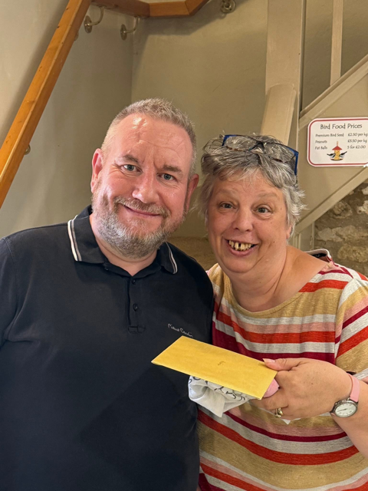
We will obviously miss Andrew very much but we have also been very lucky to welcome our newest member Sue to the team in August. A relative newcomer to Longborough but not to the area, Sue moved to the village a year ago and brings heaps of valuable retail experience from her time at The Crock Shop in Stow. She has already fitted in as though she was born for the role, and we look forward to getting to know her even better.
This month, we also say goodbye to Tyler, who, like many younger members of the village, started working in the shop when he was 14 on Saturdays and this summer has stepped in to cover holidays and fill rota gaps. Tyler is now off to college to begin an engineering apprenticeship. Good luck, Tyler!
Happily, his twin sister Rosie will be taking over his weekend shifts. Many of you may know Rosie from the Horse and Groom, and we’re delighted to have her join us.

More Volunteers Needed
Volunteers are the heart of our shop and café. We currently have over 30 regular and occasional volunteers, plus another 20 villagers who help behind the scenes with everything from plumbing repairs to cake baking and garden care. We’re grateful for every contribution.
Its great to be part of such a warm and friendly community and we have lots of fun too.
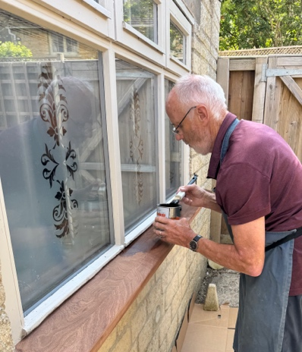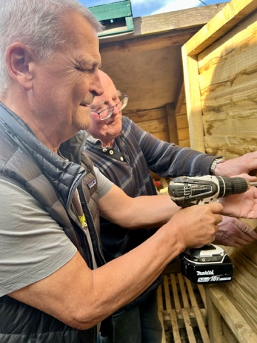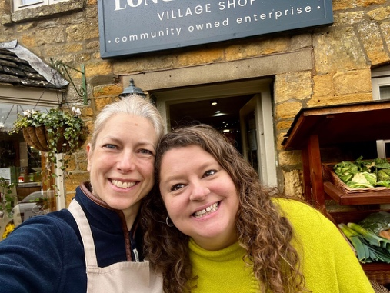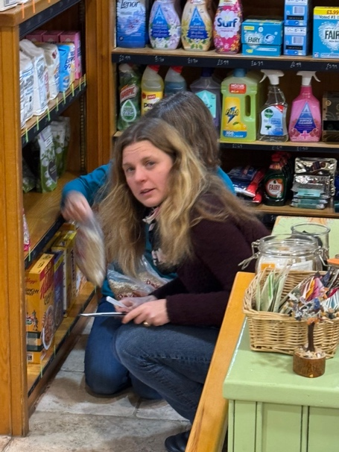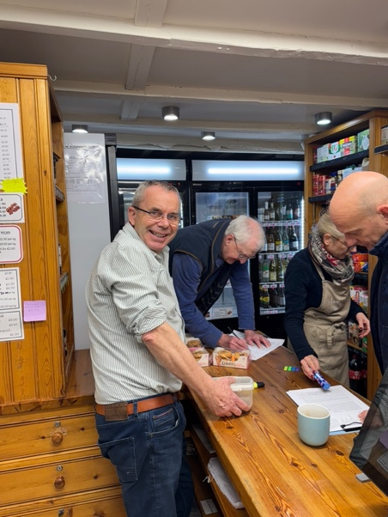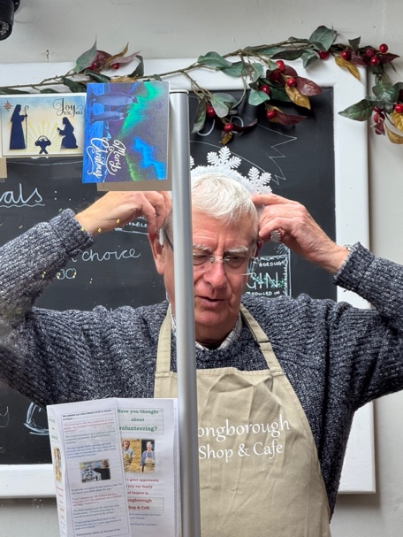
However, we have recently lost several regular helpers to new challenges and we need more hands. If you can spare a couple of hours a week—ideally on a regular or semi-regular basis—please contact Patrick on 07801 235940. Your help truly makes a difference.
Award Collection in London
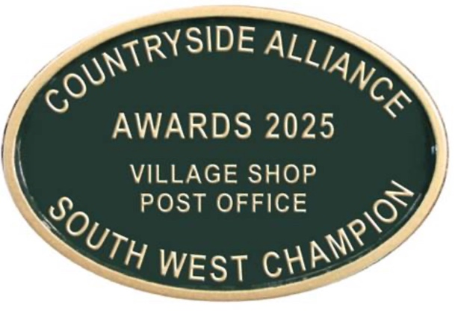

As we proudly shared last month, Longborough Village Shop won the Countryside Alliance Award for Best Village Shop in the South West. In June, a small delegation travelled to London to collect the award.
Our representatives were Anna, our longest-serving volunteer, Charles and Steve, who are regular volunteers and committee members and Becky, who has worked in the shop for over five years
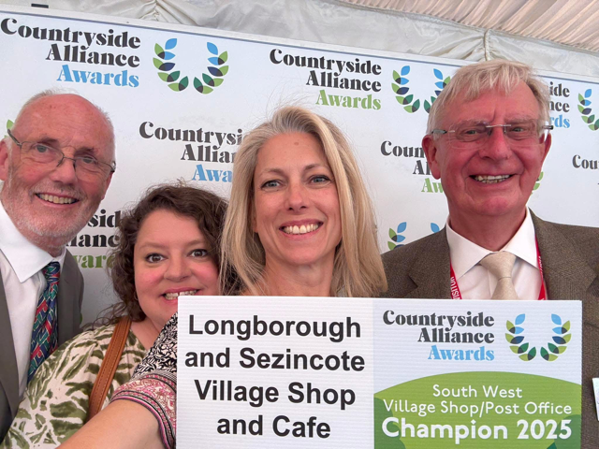
They enjoyed a wonderful day, mingling with members of the House of Lords and bringing home our prestigious award.
Kitchen Refurbishment Plans
Our kitchen, though recently awarded a 5-star hygiene certificate is beginning to show its age. With the café and garden busier than ever, we’re planning a full refurbishment after Christmas.
To help fund this, we’ll be holding a Race Evening on Thursday 26th September at the Village Hall, hosted by our chairman Richard. Keep an eye out for posters with more details.

Stuart’s Trugs
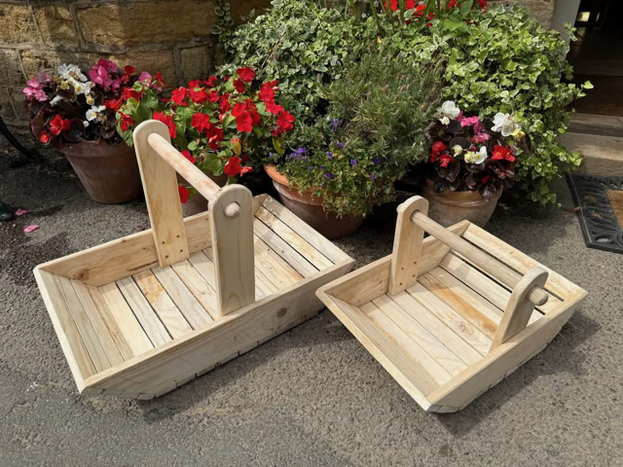
Over the summer, many of you spotted the handmade trugs created by Stuart from recycled pallet wood and old broom handles. We’ve sold over 30 so far, raising £500 towards the shop’s donations fund. A few are still available—get yours while you can!
Cake Corner
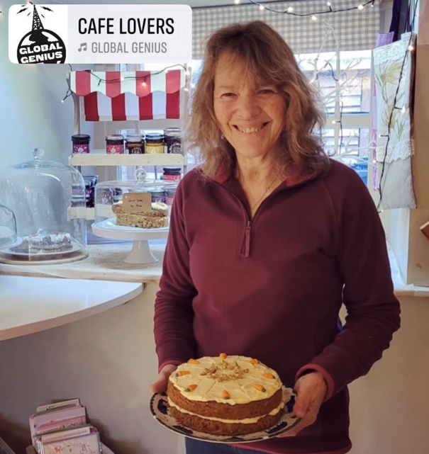
Thank you to everyone who answered our recent call for more homemade cakes. We’ve welcomed several new bakers alongside our seasoned cake-makers, and their creations have been a real hit. Remember: if you’d like us to provide the ingredients for your favourite bake, just let us know. Every cake helps make our shop offering that little bit sweeter!
Window Display
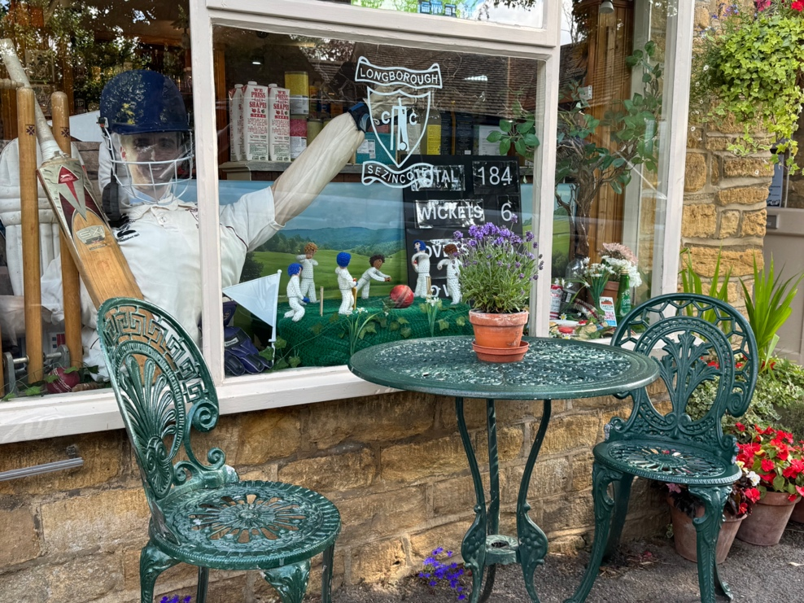
With the Moreton Show coming up, we recall our past wins for “Best Window Display” in the Moreton area. This year, we’re sitting out of the competition but Anna who is our talented window dresser is serving as a judge instead. She’ll still be creating a beautiful display for the shop because to us she’s always going to be the winner.
Finance – Half Year Update
The first six months of the year have been busy and successful for the shop and café. Sales have remained strong despite rising costs, with takings up 7% compared to the same period last year. The café continues to be a major contributor to our income, thanks to the dedicated efforts of staff, volunteers, and our wonderful bakers. Our strong performance means we can invest in improvements like the upcoming kitchen refurbishment with some much-needed support through donations.
Exceptional Opening Hours
August Bank Holiday Monday (25th August): 8:30am – 12:00pm
From Sunday 26th October onwards: 9,00am – 12pm (Sundays only) All other days remain as normal.
Dates for Your Diary
26th September – Race Evening at the Village Hall
26th October – Sunday hours change
6th November – Christmas Launch Evening

